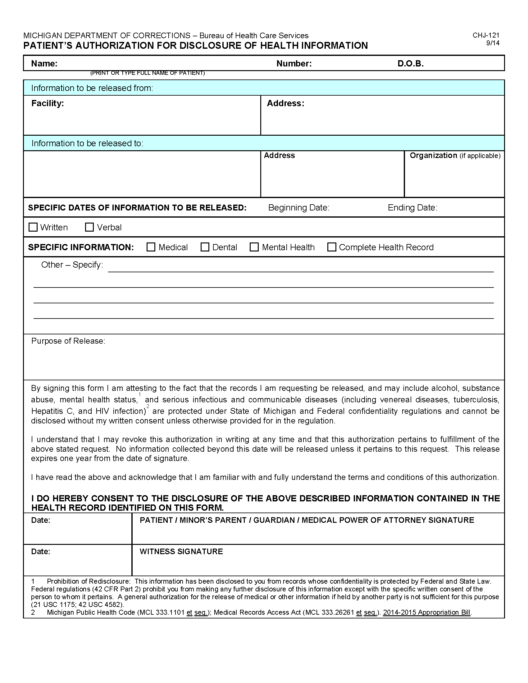

`
Order No. 01-29018 - 002
Batman
University of Michigan Hospital and Health Center
Release of Information Unit - NCAC
Axiom Requisition Copy Service
as agent of Smith and Jones PC, John Doe
2869 Jolly Road
Okemos, MI 48864
FROM 01/01/1979 TO PRESENT: Any and all MEDICAL RECORDS, including but not limited to patient history form(s), reports, etc. pertaining to Batman SSN: xxx-xx-5555, DOB: 01/01/1979.
Litigation
2901 Hubbard Street
Ann Arbor, MI 48109-0000
01/01/1979
X

